w
web development proposal
ST10515154 Baloyi Vukona

Rosebank college
Wede5020

Table of contents

• Name of the organisation 2
History of the organisation 2
Mission and Vision statements: 2
Target audience: 3
Website Goals and Objectives: 3
Present key performance to measure success: 4
Strengths and Weaknesses: 4
Areas for improvements: 5
Essential features and the desired functionality: 6
Design and User Experience: 7
User experience considerations for SPAR 7
Technical requirements: 8
Timeline and Milestones: 8
Sitemap 9
LOW-FIDELITY WIREFRAME FOR SPAR 10
15

      - Organisation overview

- Name of the organisation: SPAR

History of the organisation

SPAR started in the Netherlands in 1932 when a businessman named Adriaan van Well created a group for independent grocery store owners. His idea was to help small shops work together so they could compete with bigger businesses. The name SPAR comes from a Dutch phrase that means people benefit when they work together. In South Africa, SPAR was established in 1963, with its first store opening in Durban.

SPAR later expanded to many countries around the world. They introduced new brands like SaveMor for people who live in rural areas and Build It for people who need things to build houses. The business grew by allowing local store owners to operate under the trusted SPAR brand while still managing their own stores.

Today, SPAR is one of the most recognised retail groups in South Africa. It operates supermarkets, liquor stores, pharmacies, and other retail outlets. Our company is well known for convenience, quality products, supporting local communities, has over 4,400 stores in counties and they are good at working with the people in the communities where they have stores. SPAR has different kinds of stores like KWIKSPAR, SUPERSPAR, SPAR Express and SPAR Gourmet.

Mission and Vision statements:
SPAR’s mission is to provide customers with high-quality products at affordable prices. They are committed to delivering excellent service and offering a wide range of products that meet the needs of every community they serve. While their vision is to be the most trusted and preferred retailer in every market they operate in. They aim to achieve this by supporting local businesses, promoting sustainability, and ensuring that their products and services improve the everyday lives of their customers.

Target audience:
Spar’s target audience are people between 18 and 45 years old both men and women. Their customers are people who have jobs and like to buy good things. They like it when things are easy and convenient. They have stores that are good for single people, young families and people who care about their health.

Website Goals and Objectives:
- Increase customer convenience and reduce in-store friction:
The website should help customers plan their shopping before they leave their homes. That means easy access to weekly specials, current promotions, store trading hours, and an accurate store locator. The goal is to save customers time and make SPAR their first choice for planned shopping.
- Drive both foot traffic and online orders:
Use the website to send customers to their nearest SPAR, SUPERSPAR, KWIKSPAR, or TOPS at SPAR. At the same time, push online sales through SPAR2U by linking directly to the app and explaining how local delivery works. The goal is to increase sales across channels.
- Grow the SPAR Rewards programme:
Encourage sign-ups and active use of SPAR Rewards. The site should explain benefits clearly, show current e-coupon deals, and make joining simple. The goal is to build a database of loyal customers we can communicate with directly.
- Provide value beyond price:
Position SPAR as a helpful brand, not just a shop. Include Fresh line meal ideas, braai tips, budget recipes and seasonal content like Easter or Christmas guides. The goal is to increase repeat visits and time spent on the site.
- Strengthen the “local store, global brand” message:
Show that each SPAR is locally owned while backed by an international group. Highlight community sponsorships, school support, and local owner stories, and the goal is to build emotional connection and trust with shoppers.
- Support other SPAR services:
Make customers aware of in-store services like, kiosk for airtime/electricity, TOPS at SPAR, Pharmacy at SPAR, Build It. The goal is to increase awareness and usage of full SPAR ecosystem.

Present key performance to measure success:
- Monthly website visitors- Check how many people visit the site each month. More visitors usually mean more interest in SPAR’s stores and specials.
- Store locator clicks-Track how many people use the “Find a Store” button. This shows customers are planning to visit a SPAR near them.
- SPAR2U app clicks-Measures how many people click from the website to download the SPAR2U app. This tells us if the site is helping grow online orders.
- SPAR Reward sign-ups- Count how many new customers join SPAR Rewards through the website each month. This shows if we are building customer loyalty online.
- Time spent on the site- See how long people stay on the website. If they spend a few minutes on recipes or specials, the content is useful.
- Bounce rate-Check how many people leave after only one page. A lower number means the site is keeping people interested.
- Mobile users- Make sure most visitors are on their phones. This shows the site works well for everyday shoppers.

Strengths and Weaknesses:
Strengths:
  - The SPAR logo and colours are used consistently so people know it is the SPAR website.
  - The website has sections for different types of products like groceries and promotions, and it is easy to find the store locator.
  - The website has information that is relevant to people in South Africa like regional offers and community involvement.
  - The website has some things in place to help it show up in search engines.
  - The website looks okay on phones because the layout adjusts to screens.
Weaknesses:
  - The website takes time to load because the pictures are too big which makes people leave the site and it hurts the search engine rankings.
  - Some of the graphics and user interface elements look old which makes the site look less professional.
  - The website does not have calls to action like “buy now” or “sign up” to guide visitors to make purchases or sign up.
  - The website does not have a way to track what people are doing on the site so SPAR cannot see how well the site is doing.
  - The website is not very accessible to people with disabilities because it does not have contrast and is missing some important attributes.

Areas for improvements:
  - Media optimisation-Compress SPAR banners and use modern formats (WebP) to boost loading speed.
  - Design refresh- update UI to a contemporary style that matches SPAR’s brand evolution and market trends.
  - Add strong CTAs- insert clear, action-oriented buttons on product and landing pages to drive sales and loyalty.
  - Analytics implementation – set up tools like Google Analytics and event tracking to monitor SPAR user journeys and conversions.
  - Enhance accessibility- improve colour contrast, add alternative text to SPAR images and ensure compliance with WCAG guidelines.

Essential features and the desired functionality:
- Homepage:
- Hero image
- Brief introduction
- Call to action
- Navigation menu
- About us:
- SPAR’s history, mission and team members in South Africa.

- Contact page:
- Contact form with validation for SPAR customer inquiries.
- Address with integrated Google Maps for SPAR store locations.
- Phone, email and social media links for SPAR support.

- Products/Services page:
- SPAR product catalogue with filter and sort options (category, price, promotions).
- Detailed product pages with images, specs, pricing and “Add to cart” CTA.

- Enquiries:
- Form for product/service enquiries.
- Additional SPAR Functionalities:
Search bar with autocomplete for quick SPAR product finding.
Loyalty login for personalised SPAR experiences and order tracking.
Newsletter signup for SPAR promotions with opt-in confirmation.
Performance dashboards for monitoring SPAR website analytics and sale metrics.

Design and User Experience:
The SPAR website should feel fresh, trustworthy and community-focused, reflecting the South African retail brand’s identity. The design must convey reliability while being modern and inviting to online shoppers.
- Colour scheme
Primary colour: SPAR red (#E60000) for headers and calls-to-action.
Secondary colour: soft green (#4CAF50) for promotions and eco-friendly messaging.
Accent colours: light grey for backgrounds and white for content blocks.
Accessibility: ensure enough contrast between text and background (e.g. dark text on light grey.)

- Typography
Headings: bold sans-serif font (e.g. Monsterrat Bold) for strong brand statements.
Body text: clean, readable sans-serif (e.g. Roboto Regular) for product descriptions.
Hierarchy: H1 for homepage banner, H2 for section titled, H3 for product headings; use appropriate font sizes (e.g. 32px, 24px, 18px.)

Layout and design
Grid-based layout for organised product displays and easy scanning.
Prominent hero banner showcasing SPAR specials or seasonal offers.
Consistent navigation with clear menus: Home, Products, Promotions, About Us, Store Locator, Contact.
Mobile-first design to serve South African shoppers who use smartphones.

User experience considerations for SPAR
Intuitive navigation: simple menu with dropdowns for product categories and store services.
Consistent colour use: apply the SPAR palette to guide users (e.g. red for urgency, green for savings.)
Accessibility: high contrast, readable fonts, and alternative text for product images.

Technical requirements:
Domain: Register or use an existing domain like `spar.co.za` or a suitable subdomain.
Hosting: Reliable South African web host with SSL certificate (HTTPS) for security and SEO.
Server: Choose shared hosting for a medium-size site or cloud hosting (e.g. AWS) for scalability.

Programming languages and frameworks for SPAR website:
Front-end: HTML5 for structure, CSS3 for styling, JavaScript for interactivity (e.g. jQuery or modern ES6).
Back-end: PHP or Node.js for server-side logic, with a CMS like WordPress or a custom solution for SPAR content management.
Database: MySQL or PostgreSQL to store product information, user accounts, and orders.
E-commerce: Integrate a simple shopping cart system (e.g. WooCommerce if using WordPress) for SPAR products.

Timeline and Milestones:
Week number | Phase | Milestone
1 | Planning | Proposal completed
2 | Gathering of information and resources | Completed research section
3 | Designing stage | Completed wireframes
4 | Development part 1 | Completed the HTML structure
5 | Development part 2 | Completed CSS
6 | Development part 3 | Completed JavaScript
7 | Testing | Functioning website
8 | Final touches and submission | Final work submitted

Development | R120 000
Hosting (initial year) | R8 400
Maintenance | R18 000
Total estimated budget | R146 400

Sitemap

LOW-FIDELITY WIREFRAME FOR SPAR

Homepage wireframe

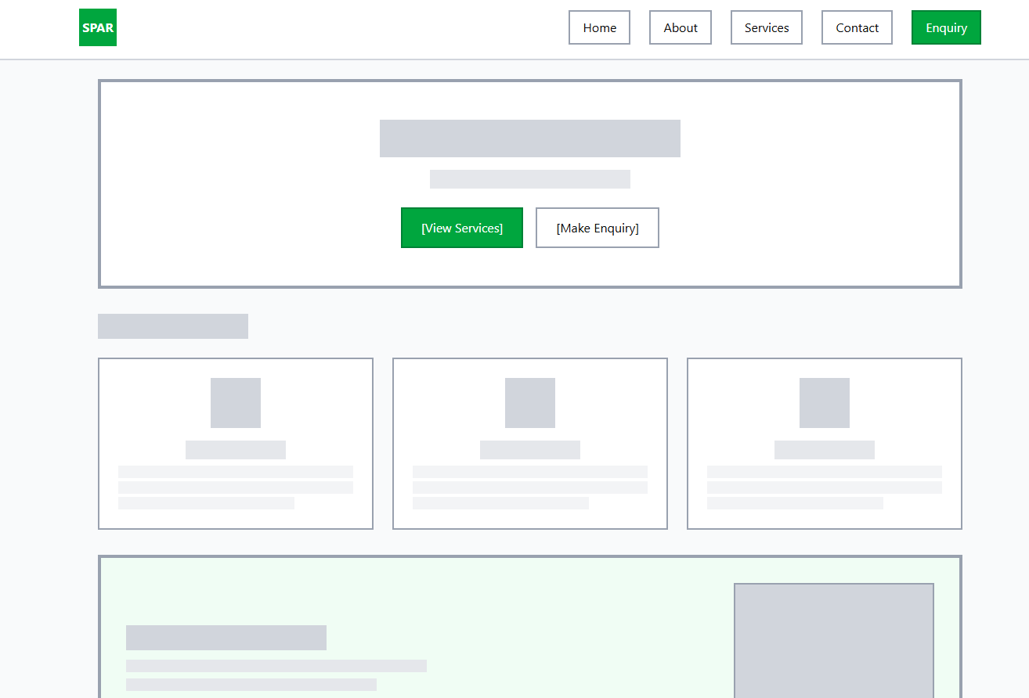

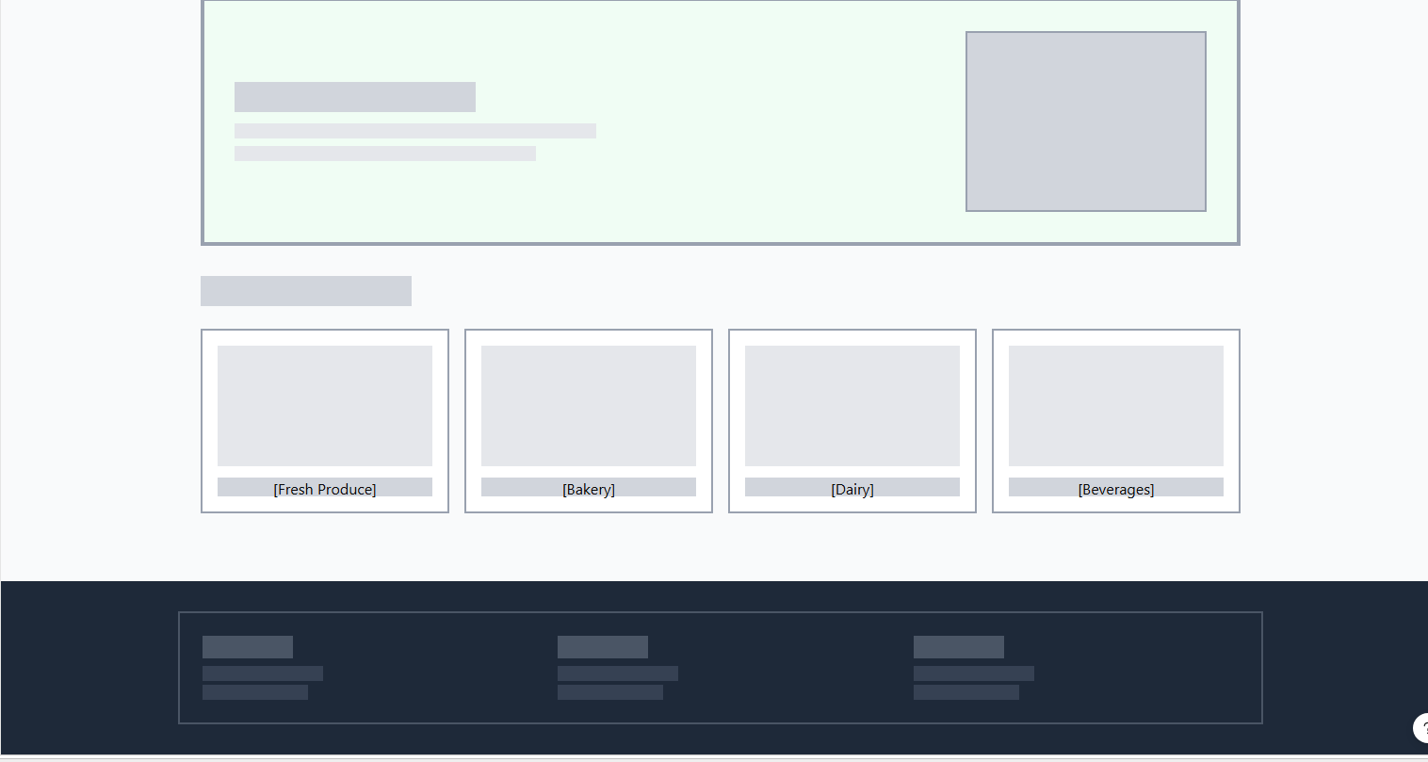

About wireframe
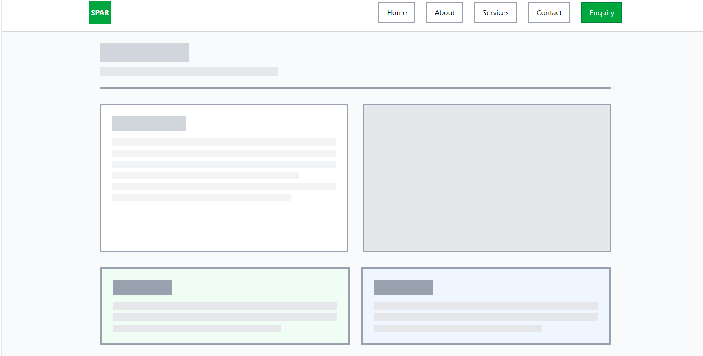

Services wireframe

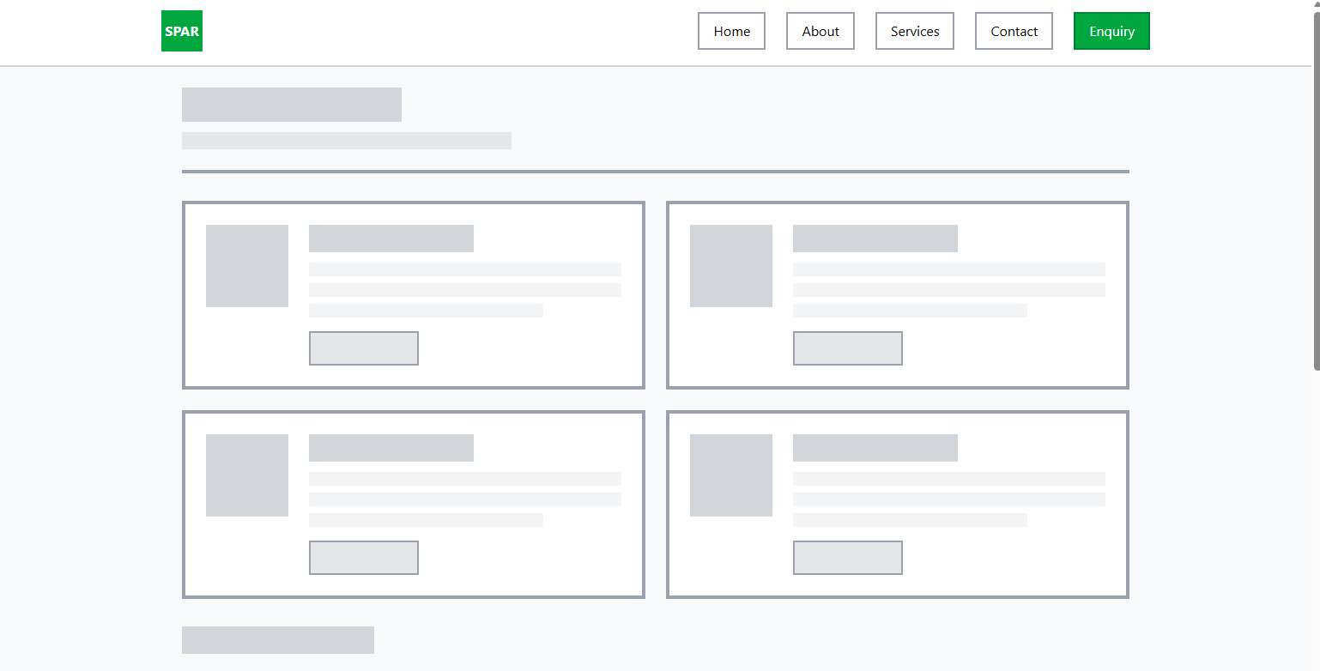
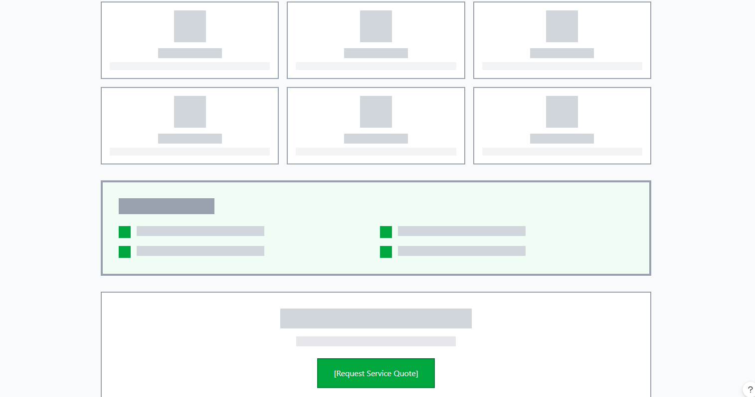



Contact wireframe
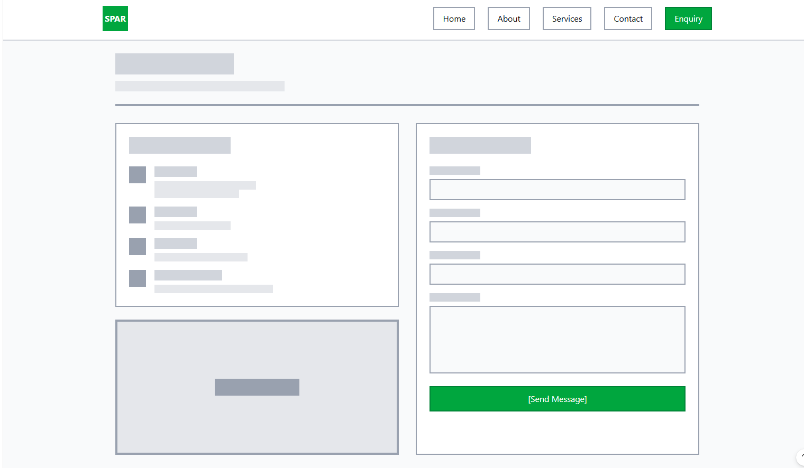

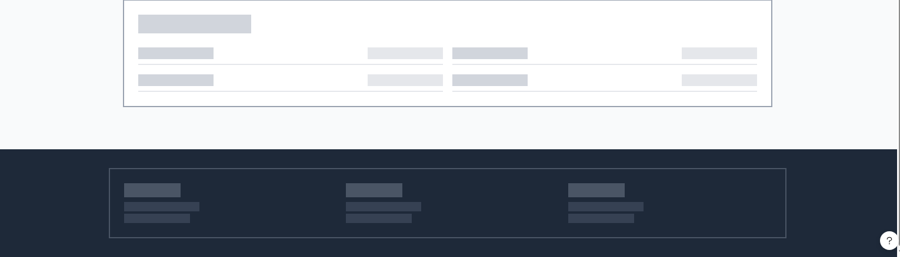

Enquiry wireframe

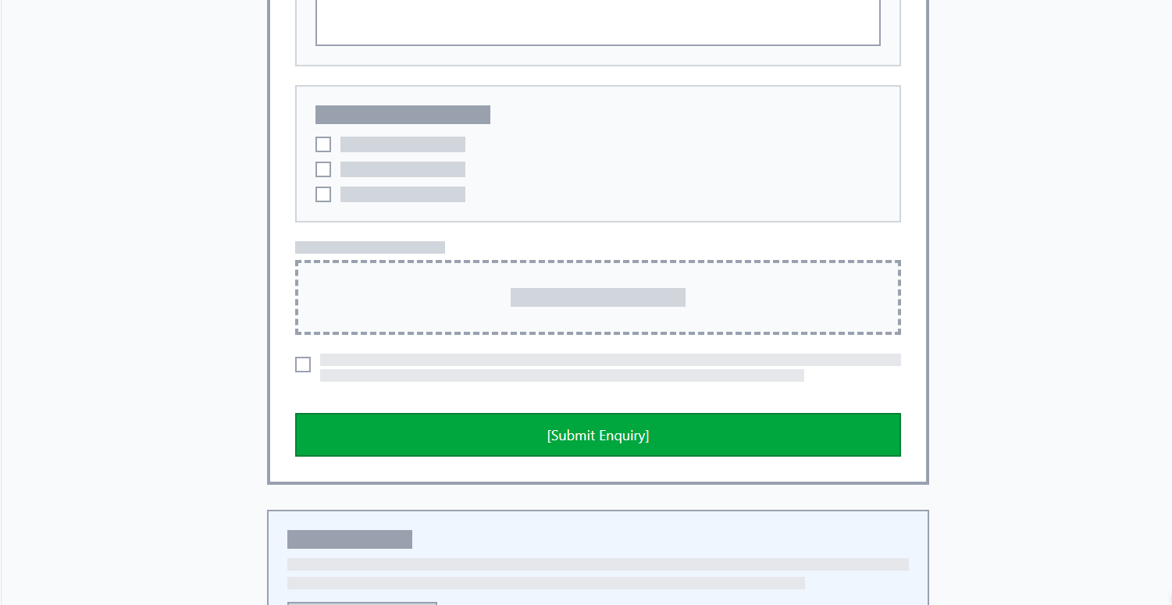


References:

SPAR International, n.d. Our history. Available at: https://www.spar-international.com (Accessed: 19 April 2026).
The SPAR Group Ltd, n.d. About us: History and company information. Available at: https://www.spar.co.za (Accessed: 19 April 2026).
The SPAR Group Ltd, n.d. Store brands and formats. Available at: https://www.spar.co.za (Accessed: 19 April 2026).
The SPAR Group Ltd, n.d. About SPAR: Mission, vision and values. Available at: https://www.spar.co.za (Accessed: 19 April 2026).
The SPAR Group Ltd, n.d. Customer services and store formats. Available at: https://www.spar.co.za (Accessed: 19 April 2026).
SPAR International, n.d. Our purpose and values. Available at: https://www.spar-international.com (Accessed: 19 April 2026).
The SPAR Group Ltd, n.d. Official website. Available at: https://www.spar.co.za (Accessed: 19 April 2026).
The SPAR Group Ltd, n.d. SPAR Rewards. Available at: https://www.spar.co.za (Accessed: 19 April 2026).
The SPAR Group Ltd, n.d. SPAR2U online shopping and delivery services. Available at: https://www.spar.co.za (Accessed: 19 April 2026).
The SPAR Group Ltd, n.d. Store locator and trading information. Available at: https://www.spar.co.za (Accessed: 19 April 2026).
Chaffey, D. and Ellis-Chadwick, F., 2019. Digital marketing: Strategy, implementation and practice. 7th ed. Harlow: Pearson.
Kingsnorth, S., 2022. Digital marketing strategy: An integrated approach to online marketing. 3rd ed. London: Kogan Page.
The SPAR Group Ltd, n.d. Official website. Available at: https://www.spar.co.za (Accessed: 19 April 2026).
Google, n.d. Google Analytics. Available at: https://analytics.google.com (Accessed: 19 April 2026).
Google Search Central, n.d. Page experience and search engine optimisation guidelines. Available at: https://developers.google.com/search (Accessed: 19 April 2026).
World Wide Web Consortium (W3C), n.d. Web Content Accessibility Guidelines (WCAG). Available at: https://www.w3.org/WAI/standards-guidelines/wcag/ (Accessed: 19 April 2026).

Krug, S., 2014. Don’t make me think, revisited: A common-sense approach to web usability. 3rd ed. Berkeley: New Riders.
Nielsen, J., 2020. Usability heuristics for user interface design. Available at: https://www.nngroup.com (Accessed: 19 April 2026).
The SPAR Group Ltd, n.d. Official website. Available at: https://www.spar.co.za (Accessed: 19 April 2026).
Mozilla Developer Network (MDN), n.d. HTML, CSS and JavaScript documentation. Available at: https://developer.mozilla.org (Accessed: 19 April 2026).
WordPress.org, n.d. WordPress content management system. Available at: https://wordpress.org (Accessed: 19 April 2026).
WooCommerce, n.d. WooCommerce e-commerce platform. Available at: https://woocommerce.com (Accessed: 19 April 2026).
Amazon Web Services (AWS), n.d. Cloud hosting services. Available at: https://aws.amazon.com (Accessed: 19 April 2026).
World Wide Web Consortium (W3C), n.d. Web Content Accessibility Guidelines (WCAG). Available at: https://www.w3.org/WAI/standards-guidelines/wcag/ (Accessed: 19 April 2026).
Krug, S., 2014. Don’t make me think, revisited: A common-sense approach to web usability. 3rd ed. Berkeley: New Riders.
Norman, D., 2013. The design of everyday things. Revised and expanded ed. New York: Basic Books.

REFERENCES FOR THE IMAGES USED ON THE WEBSITE:
https://unsplash.com/photos/assorted-items-on-display-in-store-e4EmPx91Aj4
https://unsplash.com/photos/assorted-drinks-on-white-commercial-refrigerator-SvhXD3kPSTY
https://unsplash.com/photos/a-group-of-people-standing-in-front-of-a-store-2LfrDHerYIA
A grocery store aisle filled with lots of food photo – Food Image on Unsplash
cataloguethisweek.com

